**COMSATS University Islamabad (Lahore Campus)**



**Assignment <3>–** **Spring 2024**

|  |  |  |  |  |  |
| --- | --- | --- | --- | --- | --- |
| Course Title: | Game Development | Course Code: | CSC495 | Credit Hours: | 3(2,1) |
| Course Instructor/s: | Saira Aslam | Program Name: | BCS/BSE/BCE | | |
| **Due Date:** | **11:55 pm Sunday,**  **10th May, 2024** | **Maximum Marks:** | | **50** | |
| **Name** |  | **Reg#** | |  | |
| **Important Instructions:**   * Fill the project proposal form below * Every project will be in **GROUP OF TWO** students * If you have a different situation in your game, which does not relate the any questions below, **MENTION THAT EXCLUSIVELY.** * Submission of this form will be first phase of Assignment 3, 4 and Quiz 4 | | | | | |

**Question Marks: 20**

***CLO: <2>; Bloom Taxonomy Level: <Understanding>***

Keeping in mind the following Game of unity, which we developed in class, fill this template design for your own ***2D or 3D game*** in unity. That game will be considered as your assignment 4:

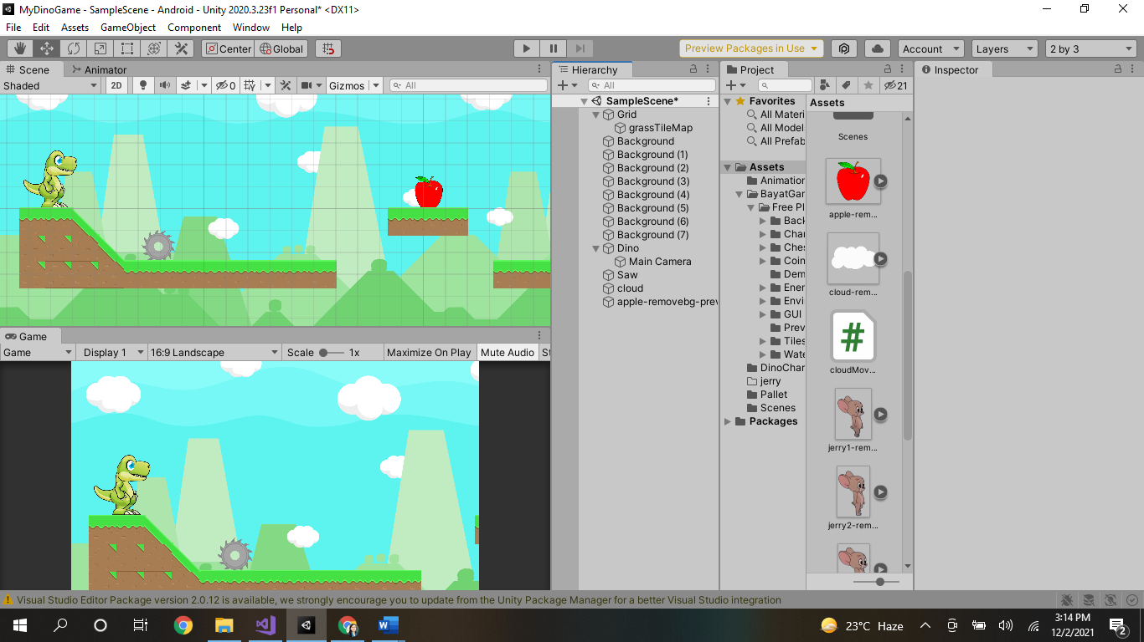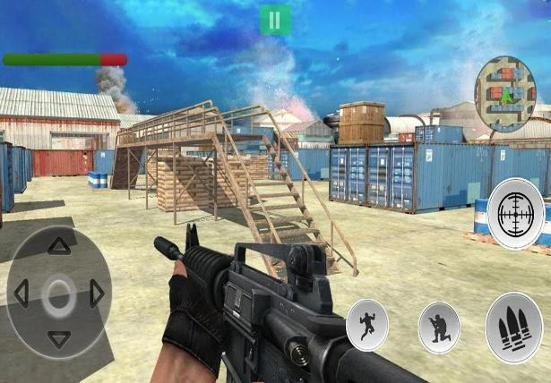

1. Group Members:

|  |  |
| --- | --- |
| **Name** | **ID** |
| Aoun Haider | FA21-BSE-133 |
| Talha Shafique | FA21-BSE-152 |

1. What 2D/3D character you want to add to your game instead of dinosaur?

**Fighter having a sword, Enemy (Spider, Giant, Skeleton) tend to kill player.**

1. What theme will you give to your game?

**In this game, players take on the role of a skilled warrior tasked with protecting himself from enemies in underground prisons that threaten their peace. Players must use their martial arts prowess to fend off waves of enemies that emerge from the shadows. With each level, players face increasingly challenging adversaries and must hone their skills to overcome them.**

1. How many Levels you want to add to your game and what difference will there be in each new level?

**3 scene will be must. One will be of main menu page, then a scene where game is played and game over. But additional scenes can be added if time is available.**

**There will be only 1 level in main scene.**

1. What Animations that character will be doing?

**Idle, walk, die, jump and attack (some other animations can also be added according to the scene semantics)**

1. What enemies you want to introduce and how you want to kill them to add score/incentives?

**Enemies will arrive in prison from secret places and the player will observe its environment to protect himself from enemies.**

1. What factor will increase or decrease the health of 2D/3D character?

**As the player is playing with sword to protect himself from enemy, different enemies will decrease power of player depending upon the enemy powers whether it is spider, skeleton or giant. Health will be increased if a player kills an enemy.**

1. Also Make a flow diagram of the levels you have designed:

